Wet Dry Vacuum Front Mount Squeegee ASM Parts
Rear Bands 2 per unit sold by the each E83685 Bend on one end.
Front Band 2 per unit sold by the each E83686 no bend either end
Latch Kit sold separately E83687

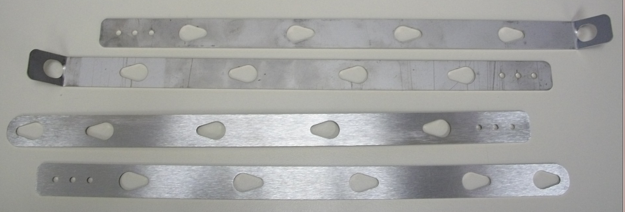
E83686
E83686
E83685
E83685

